***PAAREES PERFUMES***

***Christian Diors***

***FOR MEN***

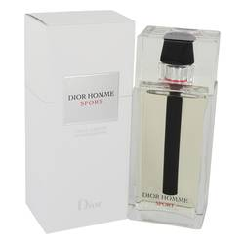

# *Dior Homme Sport*

***Description:***

Dior Homme Sport by Christian Dior Cologne. From the design house of Cristian Dior comes Dior Homme Sport, a cooling yet explosive fragrance for younger men who live an active, fun-filled lifestyle. Combining the natural scents of grapefruit, bergamot, amalfi lemon, vetiver and elemi resin, this fragrance refreshes and energizes, giving you the confident feeling you need to make it through the day. Introduced in 2008, Dior Homme Sport is recommended for daytime use and makes a great addition to your summer fragrance collection.